**Project 0501-13_DesignProposal**

**Project Name: Optimus Solutions**

**Mission Statement -**

The purpose of the Optimus Solutions Electronic Vehicle Charging database is to generate and store the required data for the EVC system which can be used for their day-to-day business operations.

**Mission Objectives** **-**

The objectives of this database management system are -

* To track total number of transactions and revenue per month
* To track total number of transactions at each location and the revenue generated from each
* To check how often a particular payment mode is used by users and the revenue by each mode
* To check how much revenue is generated by drivers with and without a permit

**ER Schema -**

**Entities, Attributes and Primary Keys -**

Location (**locationId**, locationName, address)

Driver (**driverId**, driverName, -firstName, -lastName, permit)

Vehicle (**vehicleNumber**, equippedPlugin)

Payment (**paymentId**, paymentMode, paymentAmount)

Station (**stationId**, chargingPorts)

**Relationships, Attributes, Degrees, Participating Entities and Constraints -**

**Consists:** binary relationship

1 Location to 1 or more Stations

1 Station to 1 Location

**Drives**: binary relationship

1 Driver to 1 or more Vehicles

1 Vehicle to 1 or more Drivers

**Parks:** binary relationship

1 Vehicle to 1 or more Stations

1 Station to 0 or more Vehicles

**Makes** (date, -month, -day, -year, parkingDuration, chargingDuration): ternary relationship

1 Driver and 1 Vehicle to 0 or 1 Payment

1 Driver and 1 Payment to 1 Vehicle

1 Payment and 1 Vehicle to 1 Driver

**ER Diagram -**

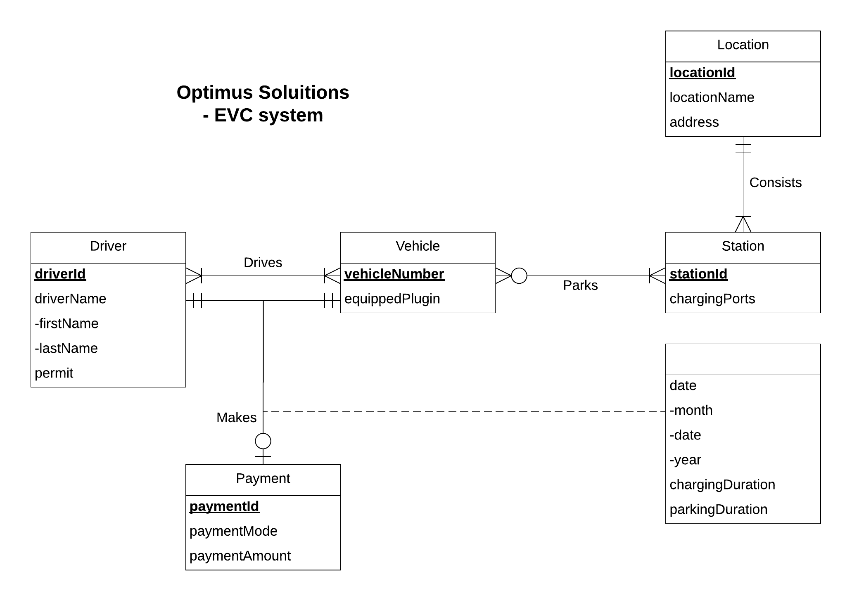

**Relations -**

Location (**locationId**, locationName, address)

Driver (**driverId**, firstName, lastName, permit)

Vehicle (**vehicleNumber**, equippedPlugin)

Payment (**paymentId**, paymentMode, paymentAmount)

Station (**stationId**, *locationId,* chargingPorts)

Drives (***driverId****,* ***vehicleNumber***)

Parks (***stationId****,* ***vehicleNumber***)

Makes (***driverId****,* ***vehicleNumber****,* ***paymentId***, month, day, year, parkingDuration, chargingDuration)

**Functional Dependencies -**

locationId —> locationName, address

driverId —> firstName, lastName, permit

vehicleNumber —> equippedPlugin

paymentId —> paymentMode, paymentAmount

stationId —> locationId, chargingPorts

stationId, vehicleNumber —>

driverId, vehicleNumber, paymentId —> month, day, year, parkingDuration, chargingDuration

**Normalization -**

Location (**locationId**, locationName, address) = 3NF

Driver (**driverId**, firstName, lastName, permit) = 3NF

Vehicle (**vehicleNumber**, equippedPlugin) = 3NF

Payment (**paymentId**, paymentMode, paymentAmount) = 3NF

Station (**stationId**, *locationId,* chargingPorts) = 3NF

Drives (***driverId****,* ***vehicleNumber***) = 3NF

Parks (***stationId****,* ***vehicleNumber***) = 3NF

Makes (***driverId****,* ***vehicleNumber****,* ***paymentId***, month, day, year, parkingDuration, chargingDuration) = 3NF

## **Business rules -**

[R1] When location information is deleted from the database, the corresponding station information is deleted.

[R2] When location information is updated from the database, the corresponding station information is updated from the database.

[R3] When vehicle information is deleted from the database, corresponding vehicle-driver information is deleted from the database.

[R4] When driver information is deleted from the database, corresponding vehicle-driver information is deleted from the database.

[R5] When vehicle information is deleted from the database, corresponding parking information should not be deleted.

[R6] When station information is deleted or updated from the database, corresponding parking information should be deleted or updated.

[R7] When driver information is deleted, corresponding driver-vehicle-payment record in should not be deleted in the “Makes” relation.

[R8] When vehicle information is deleted, corresponding driver-vehicle-payment record should not be deleted in the “Makes” relation.

[R9] When payment information is deleted, corresponding driver-vehicle-payment record should not be deleted in the “Makes” relation.

[R10] DriverId, vehicleNumber and paymentId can’t be updated.

## **Referential Integrity -**

|  |  |  |  |  |  |  |  |
| --- | --- | --- | --- | --- | --- | --- | --- |
| Relation | Foreign Key | Base Relation | Primary Key | Business Rule | Constraint: ON DELETE | Business Rule | Constraint: ON UPDATE |
| Station | locationId | Location | locationId | R1 | CASCADE | R2 | CASCADE |
| Drives | driverId | Driver | driverId | R4 | CASCADE | R10 | NO ACTION |
| Drives | vehicleNumber | Vehicle | vehicleNumber | R3 | CASCADE | R10 | NO ACTION |
| Parks | vehicleNumber | Vehicle | vehicleNumber | R5 | NO ACTION | R10 | NO ACTION |
| Parks | stationId | Station | stationId | R6 | CASCADE | R6 | CASCADE |
| Makes | driverId | Driver | driverId | R7 | NO ACTION | R10 | NO ACTION |
| Makes | vehicleNumber | Vehicle | vehicleNumber | R8 | NO ACTION | R10 | NO ACTION |
| Makes | paymentId | Payment | paymentId | R9 | NO ACTION | R10 | NO ACTION |

## **Data Entry (Sample Data) -**

**Location:**

|  |  |  |
| --- | --- | --- |
| locationId | locationName | address |
| L000000001 | Lot MV | 4116 Mowatt Ln College Park MD 20740 |

**Driver:**

|  |  |  |  |
| --- | --- | --- | --- |
| driverId | firstName | lastName | permit |
| D000000001 | James | Potter | Yes |

**Vehicle:**

|  |  |
| --- | --- |
| vehicleNumber | equippedPlugin |
| M992446 | Yes |

**Payment:**

|  |  |  |
| --- | --- | --- |
| paymentId | paymentMode | paymentAmount |
| P000000001 | ParkMobile | 3.00 |

**Station:**

|  |  |  |
| --- | --- | --- |
| stationId | locationId | chargingPorts |
| S000000001 | L000000001 | 2 |

**Drives:**

|  |  |
| --- | --- |
| driverId | vehicleNumber |
| D000000001 | M992446 |

**Parks:**

|  |  |
| --- | --- |
| stationId | vehicleNumber |
| S000000001 | M992446 |

**Makes:**

|  |  |  |  |  |  |  |  |
| --- | --- | --- | --- | --- | --- | --- | --- |
| driverId | vehicleNumber | paymentId | month | day | year | parkingDuration | chargingDuration |
| D000000001 | M992446 | P000000001 | 12 | 4 | 2019 | 6 | 3 |